Hybrid Temperature Sensor  
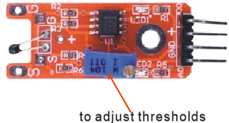

Overview

Sometimes conventionally called a “digital temperature sensor,” the hybrid temperature sensor is actually an *analog* temperature sensor, capable of reporting a voltage that varies with the outside temperature, which is then packaged a convenience circuit. This convenience circuit includes a digital switch that allows you to determine easily whether the current analog temperature exceeds some user-adjustable threshold temperature. You might prefer the digital output of a hybrid sensor to a purely analog temperature sensor in settings where you want to be able to adjust the threshold in the field. (The sensor includes a threshold dial—a variable resistor or trimpot—that allows you to alter the threshold without changing any source code on your microcontroller.) You might also use it in places where don’t want to configure an analog-to-digital converter to monitor the analog signal yourself.

In this experiment, you will use the Raspberry Pi to report on both the analog reading of the temperature sensor, as converted by the ADC0832; and the current value of the hybrid sensor’s digital threshold-detecting switch. (For more general information on analog sensors, see the Analog Temperature Sensor description.)

Material Needed

Raspberry Pi x1

Breadboard x1

Hybrid temperature sensor x1

ADC0832 x1

Dupont jumper wires

Experimental Procedure

1. If you have not done so already, prepare your development system by installing the Python interpreter, RPi.GIO library, and wiringPi library as described in READ_ME.TXT.
2. Install the ADC0832 analog/digital converter IC and hybrid temperature sensor on your breadboard, and use Dupont jumper wires to connect them to each other and your Raspberry Pi as illustrated in the Wiring Diagram below.
3. Execute the sample code stored in this experiment’s subfolder.

If using C, compile and execute the C code:  
cd Code/C  
gcc hybridTemp.c -o hybridTemp.out –lwiringPi  
./hybridTemp.out

If using Python, launch the Python script:  
cd Code/Python  
python hybridTemp.py

1. Make experimental observations. The Raspberry Pi command line output repeatedly outputs the numeric value of the analog temperature sensor. Slowly approach the sensor with an open flame (a match or candle) to increase the local temperature. Once the sensor’s digital switch reports the increased heat has exceeded a certain level, the Raspberry Pi also reports “Temperature alarm! Threshold exceeded!” Remove the heat to quiet the alarm. If you wish to calibrate your temperature alarm to other heat sources—such as body-temperature, when you gently squeeze the thermistor with your fingertips—you can experiment with different settings of the thresholddial on the sensor.

Wiring Diagram

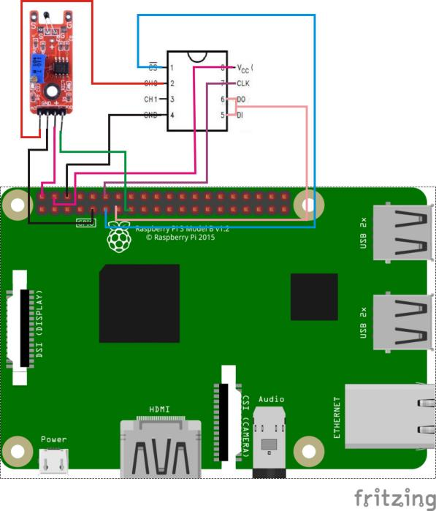

AD0382 Pin position:

CS ↔ Raspberry Pi pin 11

CLK ↔ Raspberry Pi pin 12

DO ↔ Raspberry Pi pin 13

DI ↔ Raspberry Pi pin 13

CH0 ↔ Hybrid Temperature Sensor pin "S"

VCC ↔ Raspberry Pi +5V

GND ↔ Raspberry Pi GND

Hybrid Temperature Sensor pin position:

D0 ↔ Raspberry Pi pin 15

A0 ↔ ADC0382 pin CH0

"+" ↔ Raspberry Pi +5V

GND ↔ Raspberry Pi GND

Sample Code

Python code

<<replace me once code works>>

C Code

<<replace me once code works>>